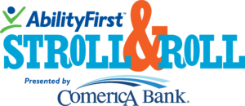
DIGITAL FILES AND SOCIAL MEDIA TOOL KIT 2024
Click on the link below to download the assets to post onto your social media
with the provided suggested copy.

INSTAGRAM /FACEBOOK – Graphics can be downloaded here
I am raising money for@AbilityFirstLA #StrollandRoll2024 to help meet critical fundraising needs in our communities for programs empowering children and adults with disabilities! Will you help me reach my fundraising goal? Please give what you can today! (insert link to your fundraising page)

I am taking action to raise funds supporting @AbilityFirstLA #StrollandRoll2024 and their mission of looking beyond disabilities, focusing on capabilities and expanding possibilities! Will you help me reach my fundraising goal? Please give what you can today! (insert link to your fundraising page)

Please donate to my @AbilityFirst #StrollandRoll2024 fundraising page and ensure that programs empowering children and adults with disabilities can continue in the future! Together we can make a difference! My (friend/sibling/loved one) is counting on me! (insert link to your fundraising page)

Can you help me raise XX more dollars to meet my fundraising goal? Today I have challenged myself to get XX donations onto my @AbilityFirstLA #StrollandRoll2024 fundraising page! Please give what you can! (insert link to your fundraising page)

